Walmart Sales Analysis – Detailed Project Report

Introduction:
This project focuses on analysing Walmart’s sales performance across different states, cities, product categories, and customer segments. The dashboard was built using Power BI to transform raw data into meaningful business insights.

Problem Statement:
Walmart needed:
- Sales trend monitoring
- Regional revenue comparison
- Customer segmentation insights
- Inventory tracking
- Forecasting future sales

Data Preparation:
- Cleaned missing values
- Created calculated columns
- Built DAX measures:
  - Total Revenue
  - MTD, QTD, YTD
  - Monthly Growth %
  - Same Period Last Year
  - Forecasting mode
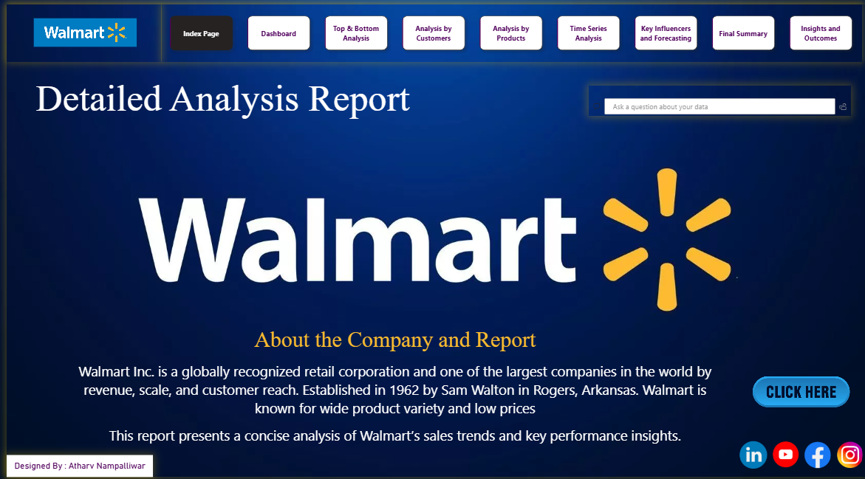

Data Modeling:
- Established relationships between:
  - Sales table
  - Customer table
  - Product table
  - Date table
- Applied Star Schema design.

Key Analysis Areas:
- Revenue Analysis
State-wise and month-wise performance evaluation.
- Customer Insights
Customer occupation, age distribution, loyalty behavior.
- Product Analysis
Stock performance, brand analysis, category comparison.
- Time Series & Forecasting
Trend analysis using forecasting model in Power BI.
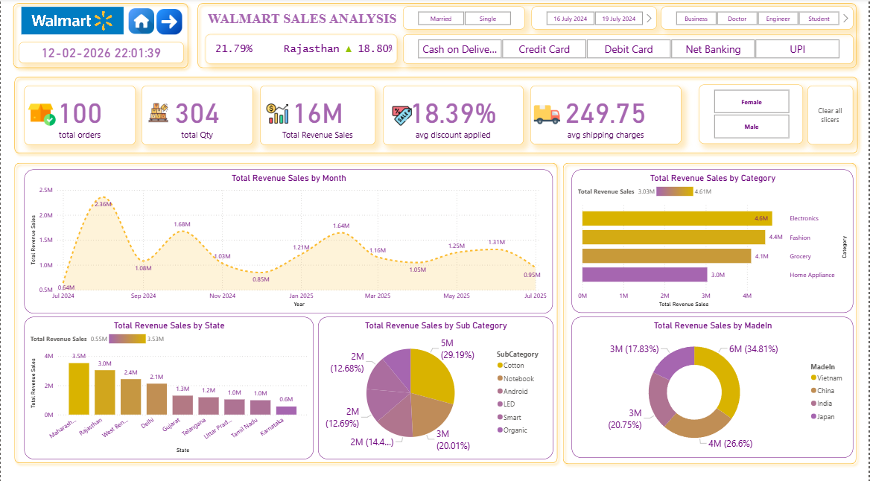
Major Findings:
- Maharashtra is the top-performing state.
- Cotton & Notebook categories drive high revenue.
- Tier 1 cities contribute majority of sales.
- Electronics & Fashion are dominant categories.
- Revenue trend shows steady annual growth.

Conclusion:
This project demonstrates:
- Strong Power BI dashboarding skills
- Data storytelling ability
- Business intelligence thinking
- KPI tracking & forecasting
- Analytical decision support

